Write the helloworld class
mkdir -p helloworld/manifests
[root@ip-172-31-3-227 manifests]# more init.pp
class helloworld {
notify { 'hello, world!': }
}

class helloworld::motd {
file { '/etc/motd':
owner => 'root',
group => 'root',
mode => '0644',
content => "hello, world!\n",
}
}
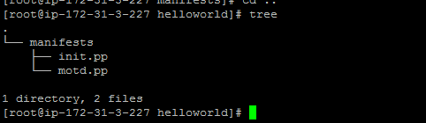

Add the helloworld and helloworld::motd classes to the main manifest

[root@ip-172-31-3-227 manifests]# more site.pp

node default {

class { 'helloworld': }

class { 'helloworld::motd': }

}

[root@ip-172-31-3-227 manifests]#
